Presidio Developer Paper
Project Title: Presidio Hotel Property Management System
Target Client: N/A

Executive Summary

The PRESIDIO is a web-based Property Management System developed by Centralized Cloud Computing International Inc. to streamline and centralize hotel operations through a unified, role-based platform. The system supports key operational departments including Administration, Front Desk, Billing, and Housekeeping, providing each role with dedicated dashboards, tools, and workflows tailored to their operational responsibilities.

PRESIDIO centralizes reservation management, guest monitoring, room assignment, housekeeping status tracking, folio and billing management, payment processing, and operational reporting within a single integrated environment. Through centralized dashboards and real-time operational monitoring, the platform provides visibility into occupancy, bookings, room statuses, guest activities, and revenue performance, enabling improved operational coordination and faster decision-making.

The platform also features an Operational Simulation Engine that enables administrators, educators, and trainees to simulate hotel workflows such as bookings, check-ins, check-outs, billing operations, and housekeeping activities. This supports onboarding, workflow testing, and hospitality training scenarios, positioning PRESIDIO as both an operational management solution and a training-oriented hotel simulation platform.

Through its web-based architecture, role-based workspaces, and centralized operational tools, PRESIDIO improves operational efficiency, reduces manual coordination, enhances workflow visibility, and supports modern hospitality management within a unified digital environment.

Architecture Overview
The system follows a Software-as-a-Service (SaaS) architecture model where hotel operations are centralized into a cloud-based web platform accessible through role-based user accounts. The architecture supports scalable multi-user access, centralized deployment, cloud-hosted services, and modular operational workspaces for different hotel departments such as Front Desk, Billing, Housekeeping, and Administration.

  - Techstack

Architecture | SaaS (Software-as-a-Service), Multi-Tenant Web Architecture
Frontend | Nuxt3, Nuxt UI v4, Tailwind CSS (via Nuxt UI), Pinia
Backend | Node.js (Express.js API), TypeScript, Sequelize ORM
Authentication & Security | JWT, bcrypt, CORS, Helmet
Database | PostgreSQL
Caching & Storage | Redis, MinIO
Analytics & Reporting | Chart.js (via Vue Chart.js), jsPDF, jsPDF AutoTable, XLSX
AI Layer | Ollama (Local LLM Inference), n8n AI Workflow Automation
Deployment & DevOps | Docker, Helm, Kubernetes (Optional)
Integration Services
Table 2.1 Techstack List

  - Architecture Diagram
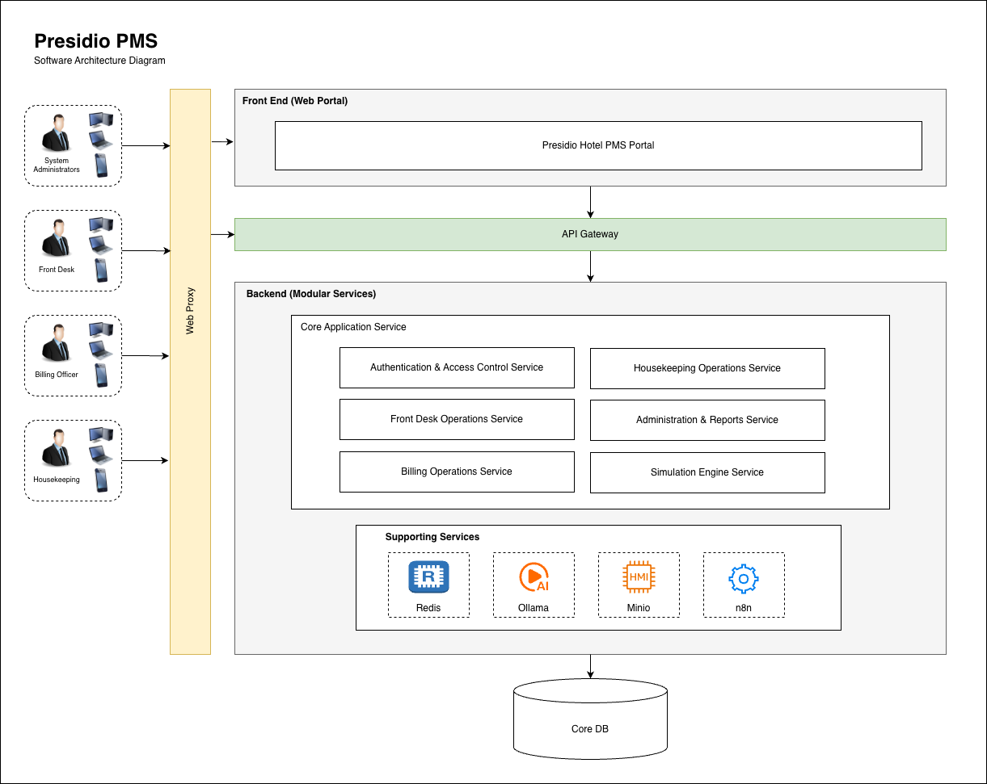

Figure 2.2 Presidio Architecture Diagram

- Modules and Key Features

Modules | Description
Profiles Management | Manages guest profiles, guest history, VIP tagging, company references, and profile-linked reservation records within the hotel management environment.
Reservation Management | Handles booking creation, reservation search, reservation modification, cancellations, room assignment, and reservation workflow coordination.
Groups & Blocks | Supports management of group reservations, room blocks, conferences, company bookings, tours, and large-scale accommodation coordination.
Front Desk Operations | Manages guest arrivals, check-in, check-out, walk-in reservations, in-house guest monitoring, and front desk coordination through centralized dashboards.
Cashier & Billing | Handles folio management, charge posting, payment processing, invoice generation, settlement workflows, and guest billing operations.
Rooms Management | Manages room occupancy, room assignment, housekeeping status, room conditions, cleaning workflows, maintenance coordination, and room monitoring.
Operational Messaging & Notifications | Supports workflow notifications, operational communication, status monitoring, and real-time updates across hotel departments.
Administration & Simulation | Provides KPI dashboards, role-based workspaces, simulation configuration, scenario testing, operational monitoring, and training-oriented workflows.
Analytics & Reporting | Generates operational summaries, occupancy monitoring, booking analytics, revenue reports, and exportable management insights.
Security & Access Control | Implements role-based authentication, access control, protected APIs, audit logging, and secure operational workflows for authorized personnel.
Table 3. Modules and Feature List

- User Roles

  - User Role List

Roles | Capabilities
Administrator | Manage users, configure system settings, manage rooms, monitor dashboards, generate reports, override folio adjustments, and configure simulation environments.
Front Desk | Create reservations, assign rooms, perform guest check-in and check-out, monitor in-house guests, and manage booking operations.
Billing Officer | Manage guest folios, post charges, apply payments, generate invoices, process settlements, and monitor billing transactions.
Housekeeping | Update room clean status, manage housekeeping tasks, flag maintenance concerns, and monitor room conditions.
Table 4.1. User Role List

  - Use case Diagram
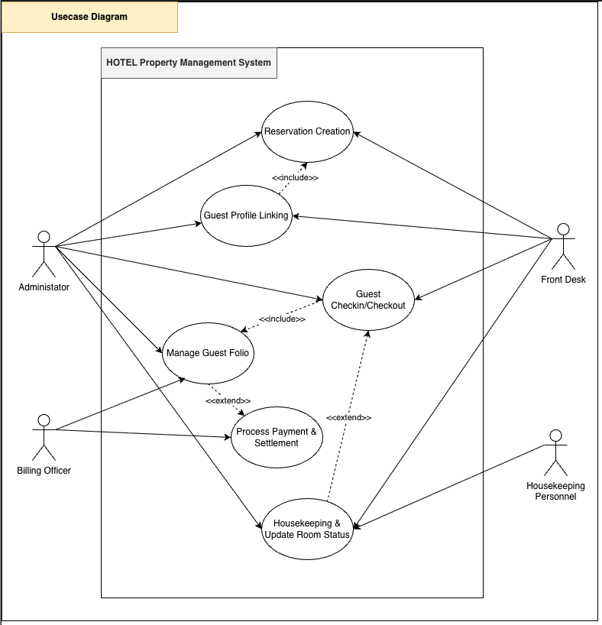
Table 4.2. Use case Diagram
https://drive.google.com/file/d/1vn0ZU8qkOThIYi-Vq4KeEYeYF4xw9-r-/view?usp=sharing

- User Stories

  - Authentication & Access
    - As a User, I should be able to log in securely using my assigned credentials.
    - As a User, I should be redirected to the correct workspace based on my assigned operational role.
    - As a User, I should be able to log out securely from the platform.
    - As an Administrator, I should be able to manage user accounts and role assignments.
    - As a User, I should be able to access either Simulation Mode or Live Operation Mode depending on my environment permissions.

  - Landing Page & Role Selection
    - As a Visitor, I should be able to access the PRESIDIO landing page.
    - As a User, I should be able to view available operational roles before entering the system.
    - As a Trainee, I should be able to enter Simulation Mode without affecting live operational data.
    - As an Educator, I should be able to use resettable demo environments for classroom training.

  - Reservation Management
    - As a Front Desk Officer, I should be able to create a reservation for a guest.
    - As a Front Desk Officer, I should be able to search existing reservations.
    - As a Front Desk Officer, I should be able to modify reservation details.
    - As a Front Desk Officer, I should be able to cancel reservations.
    - As a Front Desk Officer, I should be able to assign rooms to reservations.
    - As a Front Desk Officer, I should be able to manage walk-in reservations.
    - As a Front Desk Officer, I should be able to create group reservations and room blocks.

  - Guest Profiles
    - As a Front Desk Officer, I should be able to create guest profiles.
    - As a Front Desk Officer, I should be able to link reservations to guest profiles.
    - As a Front Desk Officer, I should be able to view guest history and previous stays.
    - As a Front Desk Officer, I should be able to tag VIP guests.

  - Check-In Operations
    - As a Front Desk Officer, I should be able to perform guest check-in.
    - As a Front Desk Officer, I should be able to verify guest identity before check-in.
    - As a Front Desk Officer, I should be able to assign vacant and clean rooms during check-in.
    - As a Front Desk Officer, I should be able to automatically generate folios upon successful check-in.

  - Check-Out Operations
    - As a Front Desk Officer, I should be able to review guest folios before check-out.
    - As a Front Desk Officer, I should be prevented from checking out guests with unpaid balances.
    - As a Front Desk Officer, I should be able to complete guest check-out workflows.
    - As a Front Desk Officer, I should be able to automatically update room statuses after check-out.

  - Billing & Folio Management
    - As a Billing Officer, I should be able to open and manage guest folios.
    - As a Billing Officer, I should be able to post additional charges to folios.
    - As a Billing Officer, I should be able to apply guest payments.
    - As a Billing Officer, I should be able to process settlements.
    - As a Billing Officer, I should be able to generate invoices and receipts.
    - As a Billing Officer, I should be able to monitor outstanding balances in real time.

  - Room Management
    - As an Administrator, I should be able to manage room records and room types.
    - As a Front Desk Officer, I should be able to monitor room occupancy statuses.
    - As a Housekeeping Personnel, I should be able to update room clean statuses.
    - As a Housekeeping Personnel, I should be able to flag rooms for maintenance.
    - As a Housekeeping Personnel, I should be able to monitor assigned cleaning tasks.

  - Housekeeping Operations
    - As a Housekeeping Personnel, I should be able to view housekeeping task assignments.
    - As a Housekeeping Personnel, I should be able to mark tasks as Pending, Ongoing, or Completed.
    - As a Housekeeping Personnel, I should be able to update room conditions after cleaning workflows.
  - Dashboard & Monitoring
    - As an Administrator, I should be able to monitor operational KPIs.
    - As an Administrator, I should be able to monitor occupancy and revenue dashboards.
    - As a Front Desk Officer, I should be able to view arrivals and departures.
    - As a Billing Officer, I should be able to monitor active folios and balances.
    - As a Housekeeping Personnel, I should be able to monitor room cleaning statuses.
  - Reports & Analytics
    - As an Administrator, I should be able to generate operational reports.
    - As an Administrator, I should be able to export reports in PDF or spreadsheet formats.
    - As an Administrator, I should be able to monitor booking and occupancy analytics.
    - As an Administrator, I should be able to review operational audit logs.
  - Simulation Engine
    - As an Administrator, I should be able to configure simulation event weights.
    - As an Administrator, I should be able to start, stop, reset, and step simulation scenarios.
    - As a Trainee, I should be able to simulate hotel workflows without affecting live data.
    - As an Educator, I should be able to use simulation environments for hospitality training exercises.
  - Notifications & Audit Logs
    - As a User, I should be able to receive operational notifications and alerts.
    - As an Administrator, I should be able to review audit trails and operational logs.
    - As a User, I should be able to view recent operational activities relevant to my role.

- Processflow

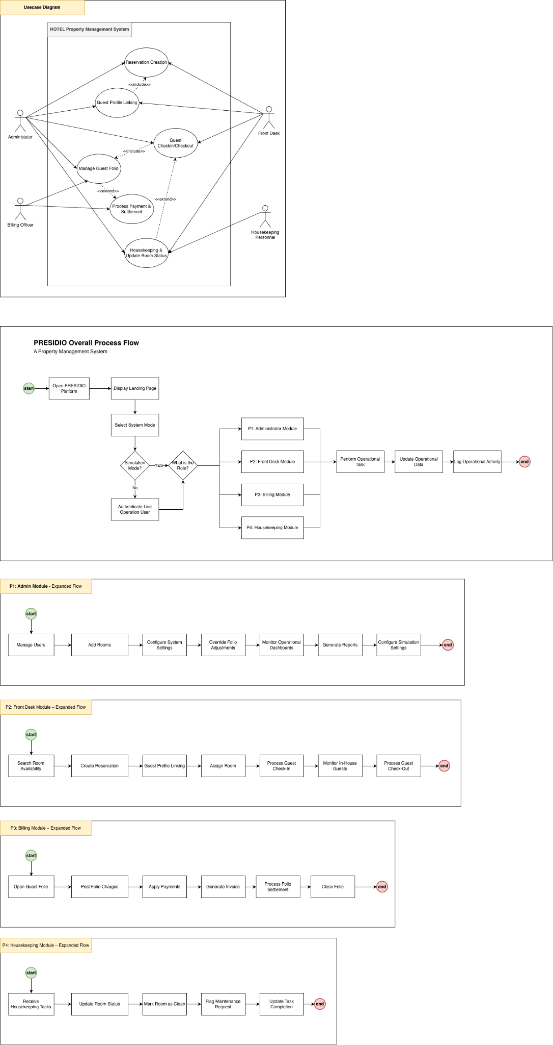
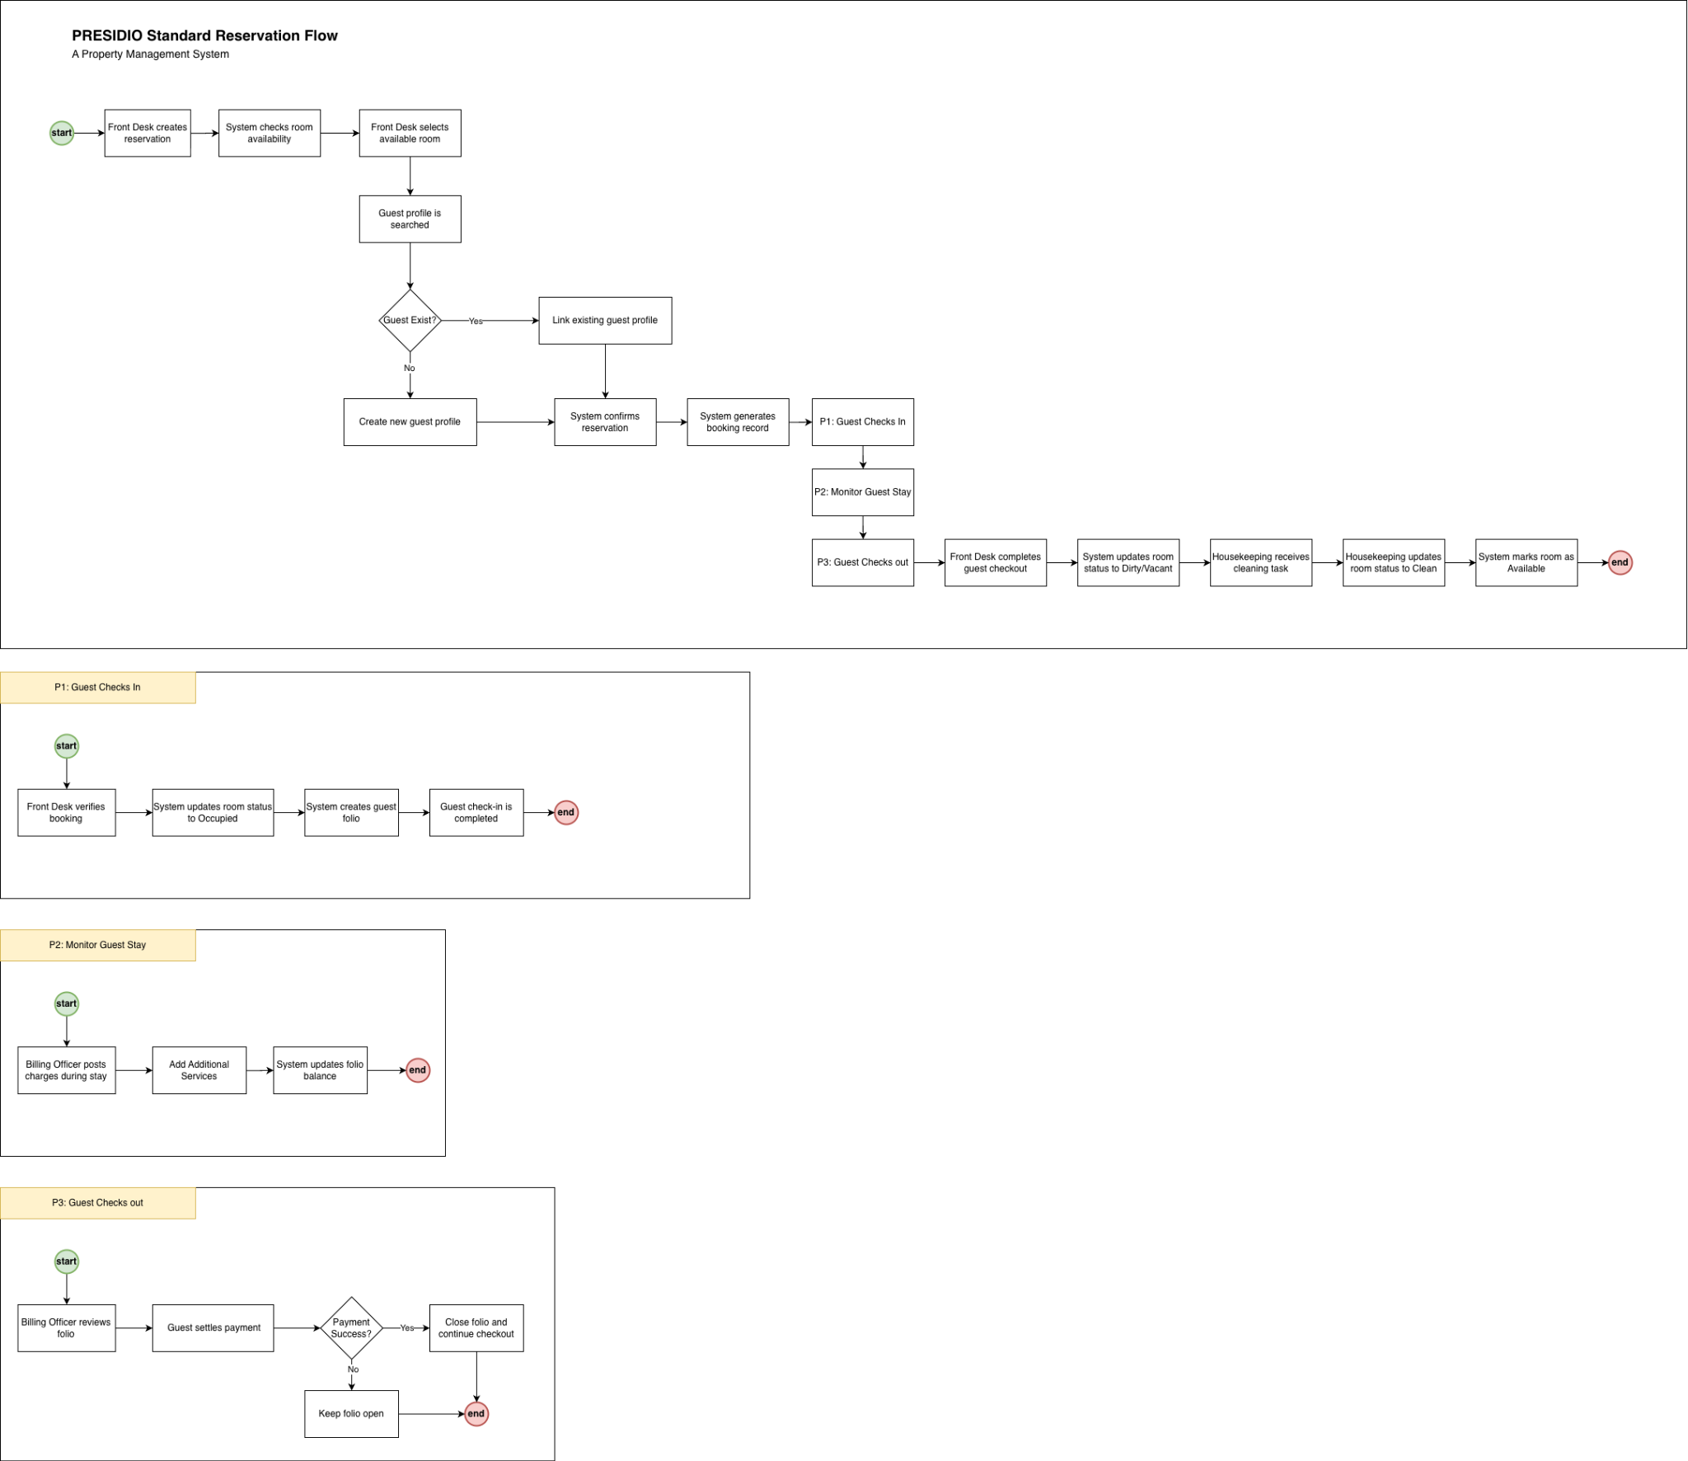
Table 6 Presidio Overall Process Flow
Table 7 Presidio Standard Reservation Flow
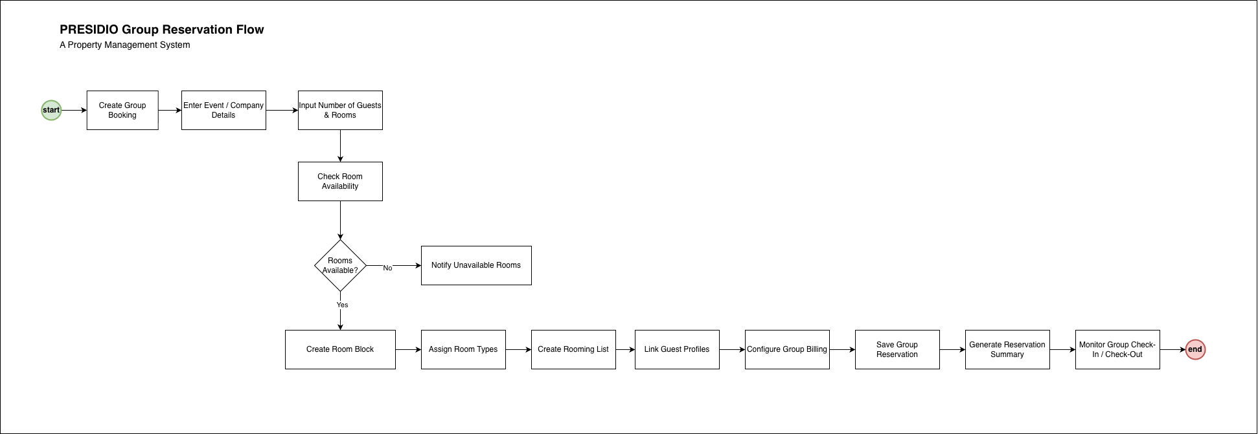
Table 8 Presidio Group Reservation Flow
6.1 Administrator Module

Table 6.1 Administrator Process Flow

6.2 Front Desk Module


Table 6.2 Front Desk Process Flow

6.3 Billing Module


Table 6.3 Billing Process Flow


6.4 Room Management and Housekeeping Module

Table 6.4 Room Management and Housekeeping Process Flow

6.5 Guest Check In Process

Table 6.5 Guest Check In Process Flow

6.6 Guest Check Out Process


Table 6.6 Guest Check Out Process Flow

6.6 Guest Check Out Process

Table 6.6 Guest Check Out Process Flow

- Entity Relationship Diagram

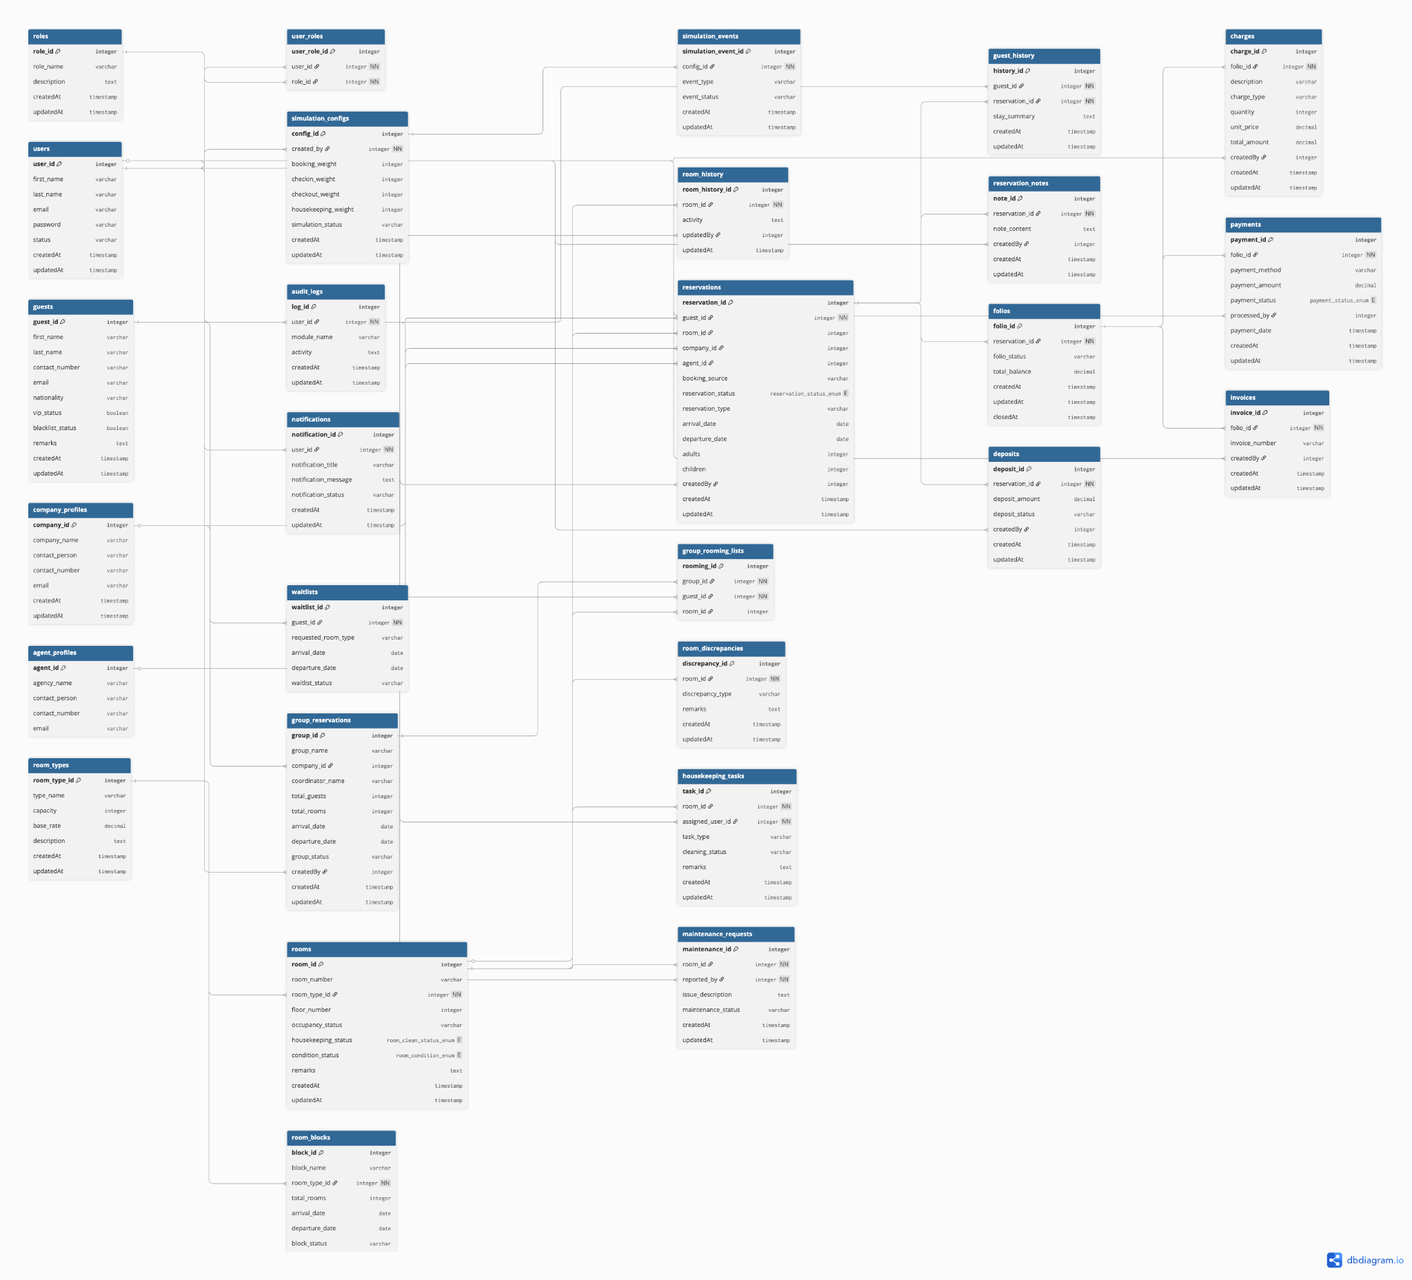
Table 7 Entity Relationship Diagram of PRESIDIO
https://dbdiagram.io/d/presidio_erd-6a0d29439f1f8ec47b59e44b

